Session 5

# An Expedition

The Amber papacy wants to launch an expedition into the mysterious ironwood. The guars however are refusing to provide protection for the expedition, but they will hire the party.

They will accompany 3 amber priests: Ella (kind, bright green eyes), Benk (tall, curious) and Donin (old, cautious)

## Permanent Storm

Dark clouds build over the road south of Nulvac. Issues can arise from that. In one place the road is flooding and must be forded.

A Nano is using a storm generator that looks like a large balloon to feed power into a large pink crystal.

*This crystal can be used to power the castle later if the party chooses to do so.*

## Electrical Sprites (optional)

Balls of energy that flit between the trees. One touch can stop a man’s heart. It is unclear if they are hostile, or curious and unaware of their own danger

If the PC’s get their attention they will begin coming toward them.

### Electrical Sprites (LV2)

Attack for 6

If hit with conductive weapons, deal 6 damage.

## Night Encounters

### Band of Culova (14+)

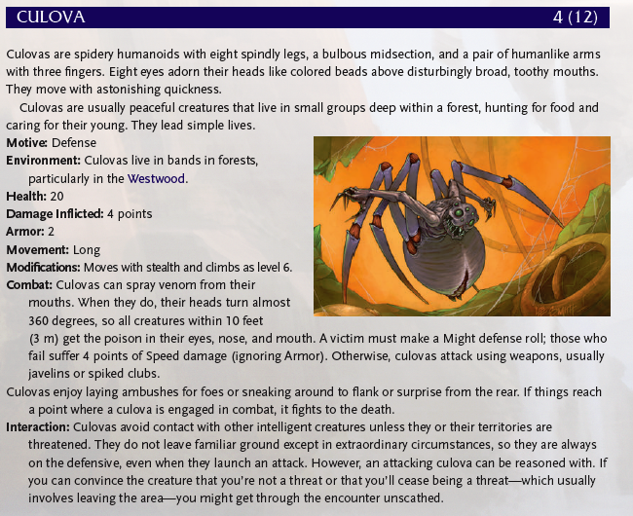

### Nibovian Companion (on a 17+)

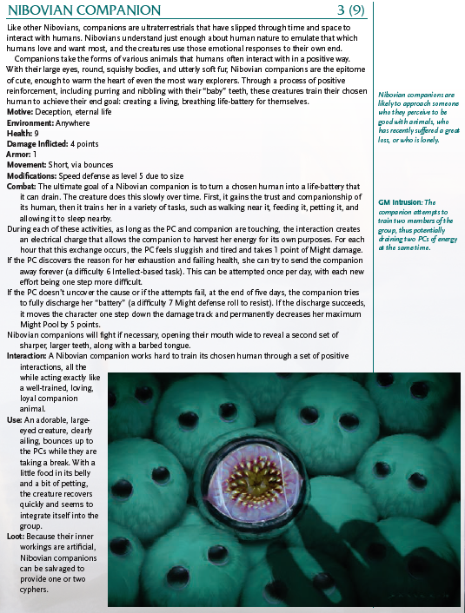

## Cultists

There are cultists in these woods wearing black and green robes. They are a radical sect of Hestans.

If followed they will eventually go back to a stone step pyramid.

## Dream Sallow

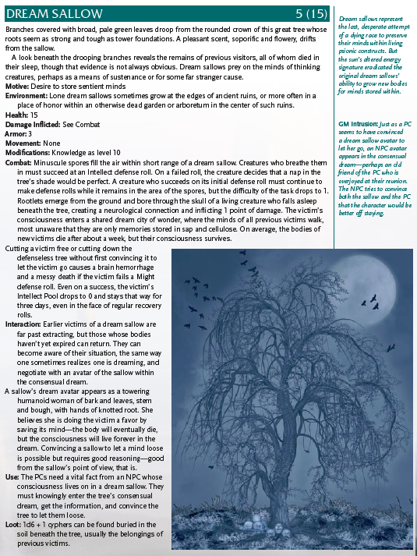

# Batos

A town in the woods created by Culova

# Back in Town

### Rumors

* Ghosts at Specter’s Peak
* Great metal face at sleeping giant
* Permanent storm on the road south
* Arsonist in Woodhaven

# Crafting

## Lightning Staff

* Pink Charge Crystal
* 20 shins
* 3 XP
* A conductive rod of some kind
* An ark capacitor

*Range: Short*

*Damage: 4 (electric)*